4. The online train reservation system allows users to search for trains by route, date, and time, and view available seats and classes. Users can register, log in, and manage their reservations through a personal dashboard. The booking process involves selecting seats, entering passenger details, and making secure payments via an integrated payment gateway. Admins can manage train schedules, seat availability, and user accounts through a comprehensive admin panel. Users receive booking confirmation emails and can view their booking history and print tickets from their dashboard. The website features real-time seat availability updates and is fully responsive for seamless use on all devices.
AIM
To design a simple Railway Reservation System webpage where users can search for trains and check a ticket’s PNR status.
HTML CODE
<!DOCTYPE html>
<html lang="en">
<head>
<meta charset="UTF-8">
<meta name="viewport" content="width=device-width, initial-scale=1">
<title>Railway Reservation System</title>
<style>
body { font: 16px Arial, sans-serif; max-width: 650px; margin: 40px auto; padding: 20px; color: #222; }
section { border: 1px solid #ddd; border-radius: 8px; padding: 20px; margin: 20px 0; }
input, select, button { padding: 10px; margin: 6px 0; }
button { cursor: pointer; }
</style>
</head>
<body>
<h1>Railway Reservation System</h1>
<section>
<h2>Search Trains</h2>
<form id="searchForm">
<input id="from" placeholder="Origin station" required>
<input id="to" placeholder="Destination station" required>
<input id="date" type="date" required>
<select id="class">
<option>Sleeper</option>
<option>AC 3 Tier</option>
<option>AC 2 Tier</option>
</select>
<button type="submit">Search</button>
</form>
<p id="searchResult"></p>
</section>
<section>
<h2>Check PNR Status</h2>
<input id="pnr" placeholder="Enter 10-digit PNR" maxlength="10">
<button onclick="checkPNR()">Check Status</button>
<p id="pnrResult"></p>
<small>Sample PNR: 4582179036</small>
</section>

<script>
document.getElementById("searchForm").addEventListener("submit", function(event) {
event.preventDefault();
const from = document.getElementById("from").value;
const to = document.getElementById("to").value;
const date = document.getElementById("date").value;
const travelClass = document.getElementById("class").value;
document.getElementById("searchResult").textContent =
`Sample train available: ${from} to ${to}, ${date}, ${travelClass}.`;
});
function checkPNR() {
const pnr = document.getElementById("pnr").value;
document.getElementById("pnrResult").textContent =
pnr === "4582179036" ? "Status: Confirmed" : "PNR not found.";
}
</script>
</body>
</html>

OUTPUT
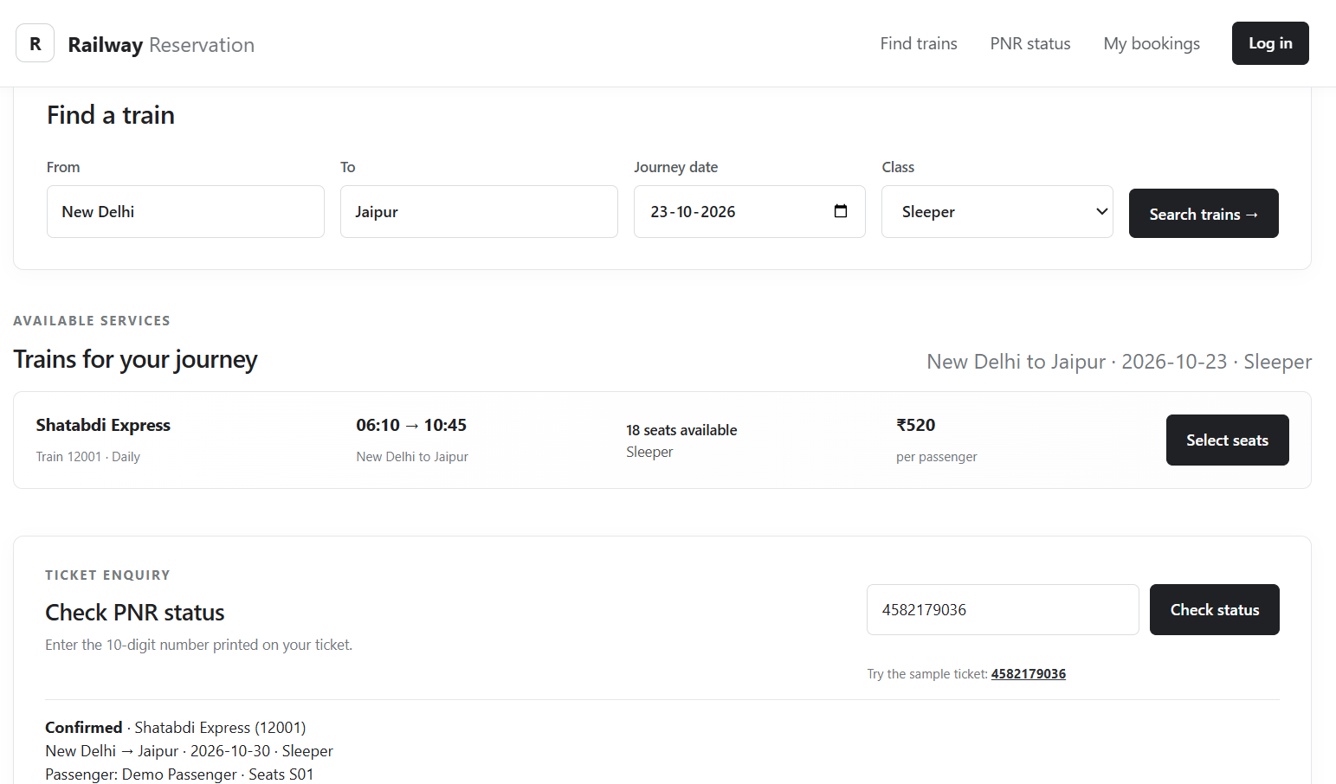
RESULT
The Railway Reservation System webpage was created successfully. It accepts train search details and displays the status of the sample PNR 4582179036.

